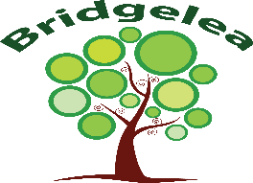

Bridgelea Primary School  Bridgelea Road  Withington  Manchester  M20 3FB | Bridgelea Primary School  Plymouth Grove West  Longsight  Manchester  M13 0AQ
Parent Communication Policy

Article 28
You have the right to a good quality education. You should be encouraged to go to school to the highest level you can.
Article 29
Your education should help you use and develop your talents and abilities. It should also help you learn to live peacefully, protect the environment and respect other people.
Article 31
You have the right to play and rest.

Implemented | SLT
Presented by | Headteacher
Ratified by Governors
Review Date

Bridgelea Primary School Vision & Mission Statement

Our overall vision of 'Understanding People' captures our core purpose perfectly. At Bridgelea we want to help our children, families, and communities to understand themselves and others more, whilst keeping their understanding of the statutory and wider curriculum.
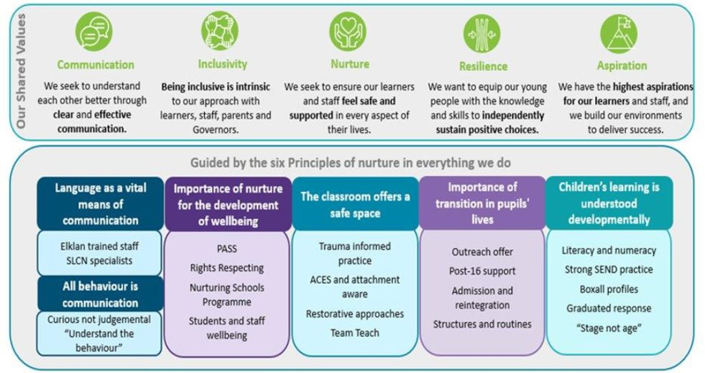

Gold Rights Respecting School

Through the School Council the children decided they would like to focus on the following 10 Articles, whilst understanding no right is more important than another:

Article 12
You have the right to give your opinion, and for adults to listen and take it seriously.
Article 13
You have the right to find out things and share what you think with others, by talking, drawing, writing or in any other way unless it harms or offends other people.
Article 15
You have the right to choose your own friends and join or set up groups, as long as it isn't harmful to others.
Article 24
You have the right to the best health care possible, safe water to drink, nutritious food, a clean and safe environment, and information to help you stay well.
Article 27
You have the right to food, clothing, a safe place to live and to have your basic needs met. You should not be disadvantaged so that you can't do many of the things other kids can do.
Article 28
You have the right to a good quality education. You should be encouraged to go to school to the highest level you can.
Article 29
Your education should help you use and develop your talents and abilities. It should also help you learn to live peacefully, protect the environment and respect other people.
Article 30
You have the right to practice your own culture, language and religion - or any you choose. Minority and indigenous groups need special protection of this right.
Article 31
You have the right to play and rest.
Article 39
You have the right to help if you've been hurt, neglected or badly treated.

The Six Principles Of Nurture

The nurturing approach offers a range of opportunities for children and young people to engage with missing early nurturing experiences, giving them the social and emotional skills to do well at school and with peers, develop their resilience and their capacity to deal more confidently with the trials and tribulations of life, for life.

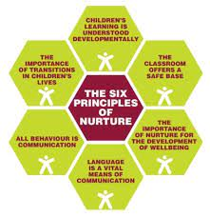

Equality and Accessibility

Our school aims to treat all pupils fairly and with respect. This involves providing access and opportunities for all pupils without discrimination of any kind. Our school is committed to ensuring staff are trained in equality issues with reference to the Equality Act 2010, including understanding disability issues.
At Bridgelea we ensure the accessibility of the curriculum, physical environment and information for pupils with special educational needs and disabilities.
Bridgelea Primary School will:
- recognize the potential for vulnerable pupils, reduce barriers to their achievement and inclusion and develop a strong culture for success
- focus on enhancing the life chances of their most vulnerable children
- plan for and teach children with learning needs through a range of proven interventions
- use a range of inclusive teaching strategies
- take an informed view of the possible literacy and mathematic interventions that will be utilized
- ensure effectively support transition of vulnerable children and young people
- evaluate a range of outcomes of their current additional provision and the value for money it provides; make informed decisions about how best to target available funding in the future
- provide professional development for staff and governors
- keep parents and carers informed in line with the school policies and the requirements of the 0 – 25 Code of Practice
The Equality Act defines an individual as disabled if he or she has a physical or mental impairment that has a ‘substantial’ and ‘long term’ adverse effect on his or her ability to undertake normal day to day activities.
Bridgelea Primary School will make reasonable adjustments for pupils with disabilities under the Equality Act 2010, to alleviate any substantial disadvantage that a disabled pupil faces in comparison with non-disabled pupils.

Communication Policy and Code of Conduct for Parents and Carers

At Bridgelea Primary School we are fortunate to have a dedicated and supportive school community. At our school the staff, governors, parents and carers alike recognise that the education of our children requires an excellent partnership between all these parties. As a partnership, we are all aware of the importance of good working relationships. Any relationship relies on good communication and this also applies to the relationship between schools and parents.

For these reasons we welcome and encourage parents and carers to participate fully in the life of our school. The purpose of this policy is to provide a reminder to all parents, carers and visitors to our school about the expectations around the conduct of all parents and visitors connected to our school.

How our school communicates with parents
Communication is hard to get right every time but please understand that we are aiming at perfection! Face to face communication is usually the best option when talking to us because it leaves less room for confusion. Every morning and evening, members of our senior team are available to speak with families on the school gates and via telephone. Parents can also speak to teachers or teaching assistants by contacting the main school office or during handover on collection. We give families regular updates which offer information and which share the highlights of life in school.

These are the ways we communicate with families:

Our website: Parents and the public can find up-to-date information about our school, our policies and practices on our website.

Reach More Parents (RMP): All parents are invited to sign up to Reach More Parents. Whole-school letters and updates are shared with parents via the RMP platform and parents receive alerts to their email addresses. We send home whole-school letters several times each term. If you are not signed up for RMP, please contact the school office. We will not be using any other electronic mailing method to communicate with families.

Phone: When we need to speak to parents individually, we phone them. It is important we have up to date phone numbers for families and emergency contacts - please let us know if your details change.

Text: Occasionally we will text parents if we need to get an urgent message out to families quickly.

How parents, carers and families can contact our school
This table outlines the best ways for you to contact us if you have a question or comment to make or if you would like to arrange a meeting:

I want to… | Speak to my child’s teacher | Find out about a class event | Find out about a whole school event | Speak to a member of the admin/ attendance teams (about absences, payments, school trips etc.) | Learn more about a school policy/ practice | Speak to a member of the pastoral or senior team
Brief face to face chat at the beginning or end of the day | ✔ |  |  |  |  | ✔
Call the school (phone) | ✔ |  |  | ✔ |  | ✔
Arrange a meeting by phoning the school |  |  |  | ✔ |  | ✔
Reach More Parents (direct messaging) | ✔ | ✔ | ✔ | ✔ | ✔ | ✔
Look on the website |  |  |  |  | ✔

If your child is not able to attend school, ALL pupil absences including sickness, medical appointments, holiday requests and exceptional circumstances MUST be reported via the Reach More Parents app.

INSERT SCREENSHOT

Why communication is important
We understand that everyday frustrations can cause misunderstandings and have a negative impact on our relationships with families. At Bridgelea, we are committed to resolving difficulties in a constructive manner through open positive dialogue. In this way we can avoid further misunderstandings and ensure that the children’s needs are met in every circumstance. Our school already has a code of conduct for all our employees but this particular code is aimed at the wider school community so that all can see and understand the expectations for the behaviour of all visitors or those connected with the school. The policy aims to clarify the types of behaviour that will not be tolerated and seeks parental sign-up to these expectations. The policy also sets out the actions the school can take, should this code be ignored or where breaches occur.

Behaviour that will not be tolerated:
- Disruptive behaviour which interferes or threatens to interfere with any of the school’s normal operation or activities anywhere on the school premises.
- Any inappropriate behaviour on the school premises.
- Using loud or offensive language or displaying temper.
- Threatening in any way, a member of staff, visitor, fellow parent/carer or pupil.
- Damaging or destroying school property.
- Sending abusive or threatening emails or text/voicemail/phone messages or other written communications (including social media) to anyone within the school community.
- Defamatory, offensive or derogatory comments regarding the school or any of the pupils/parents/staff/governors at the school on social media or other sites
- The use of physical, verbal or written aggression towards another adult or child. This includes physical punishment of your own child on school premises.
- Approaching someone else’s child in order to discuss or chastise them because of the actions of this child towards their own child. (Such an approach to a child may be seen to be an assault on that child and may have legal consequences)
- Smoking, taking illegal drugs or the consumption of alcohol on school premises. (Alcohol may only be consumed during authorised events)

Together we create a positive and uplifting environment not only for the children but also all who work and visit our school. Please note: parents / carers must make sure all persons collecting their children are aware of this policy.

What happens if someone ignores or breaks the code?
- In the event of any parent/carer or visitor of the school breaking this code, then proportionate actions will be taken as follows:
- In cases where the unacceptable behaviour is considered to be a serious and potentially criminal matter the concerns will in the first instance be referred to Greater Manchester Police. This will include any or all cases of threats or violence and actual violence to any child staff or governor in the school. This will also include anything that could be seen as a sign of harassment of any member of the school community, such as any form of insulting social media post or any form of social media cyber bullying.
- In cases where evidence suggests that behaviour would be tantamount to libel or slander then the school will consider its options for taking legal action.
- In cases where the code of conduct has been broken then the school will send out a formal letter to the parent/carer with an invitation to a meeting.
- Following the meeting, if necessary, the school will write to the parent/carer and ask them to stop the behaviour causing the concern and warn that if they do not they may be banned from the school premises.

Issues of conduct with the use of Social Media

Most people take part in online activities and social media. It’s fun, interesting and keeps us connected. There are various online school groups managed by parents for parents, such as school Facebook pages and WhatsApp groups, and they can be a wonderful source of knowledge, support and advice. We encourage you to engage with these positively if you wish. Within these spaces however we ask that you use common sense when discussing school life online. Think before you post.

We ask that social media, whether public or private, should not be used to voice complaints against the school, school staff, parents or pupils. We take very seriously inappropriate use of social media by a parent to publicly humiliate or criticise another parent, pupil or member of staff.

If parents have any concerns about their child in relation to the school as we have said above they should:
- Initially contact the class teacher
- If the concern remains they should contact the head teacher
- If still unresolved, the school governors through the complaints procedure They should not use social media as a medium to air any concerns or grievances.

Online activity which we consider inappropriate:
- Identifying or posting images/videos of pupils
- Abusive or personal comments about staff, pupils or other parents
- Bringing the school into disrepute
- Posting defamatory or libelous comments
- Emails circulated or sent directly with abusive or personal comments about staff or pupils
- Using social media to publicly challenge school policies or discuss issues about individual children
- Threatening behaviour, such as verbally intimidating staff, or using bad language
- Breaching school security procedures

We also ask that parents model appropriate use of social media and/or online platforms to their children by being kind, respectful and considerate. This in turn will support children to understand/mirror what we expect in our school community with regard to their own online behaviour.

What if parents or carers want to complain?
We have a separate complaints policy which is shared with parents and carers each year. Families should email school or ask to speak to a member of the senior team if they feel that their child’s class teacher has been unable to resolve an issue.

At our school we take our safeguarding responsibilities seriously and will deal with any reported incidents appropriately in line with the actions outlined above, as well as our school Safeguarding and Child Protection Policy.

We thank you for your cooperation in adhering to the above code of conduct.

