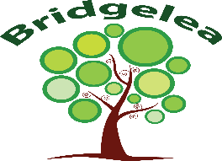

Bridgelea Primary School  Bridgelea Road  Withington  Manchester  M20 3FB | Bridgelea Primary School  Plymouth Grove West  Longsight  Manchester  M13 0AQ

SEND Information Report

Implemented | SLT
Presented by | Amy Robinson
Ratified by Governors | Autumn 2025
Review Date | Autumn 2026

Our overall vision of 'Understanding People' captures our core purpose perfectly. At Bridgelea we want to help our children, families, and communities to understand themselves and others more, whilst keeping their understanding of the statutory and wider curriculum.
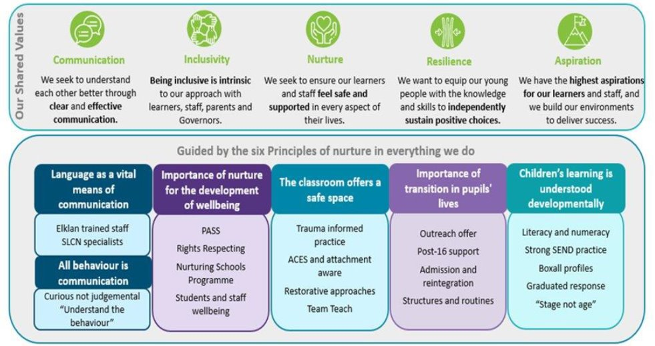

Gold Rights Respecting School

Through the School Council the children decided they would like to focus on the following 10 Articles, whilst understanding no right is more important than another:
Article 12
You have the right to give your opinion, and for adults to listen and take it seriously.
Article 13
You have the right to find out things and share what you think with others, by talking, drawing, writing or in any other way unless it harms or offends other people.
Article 15
You have the right to choose your own friends and join or set up groups, as long as it isn't harmful to others.
Article 24
You have the right to the best health care possible, safe water to drink, nutritious food, a clean and safe environment, and information to help you stay well.
Article 27
You have the right to food, clothing, a safe place to live and to have your basic needs met. You should not be disadvantaged so that you can't do many of the things other kids can do.
Article 28
You have the right to a good quality education. You should be encouraged to go to school to the highest level you can.
Article 29
Your education should help you use and develop your talents and abilities. It should also help you learn to live peacefully, protect the environment and respect other people.
Article 30
You have the right to practice your own culture, language and religion - or any you choose. Minority and indigenous groups need special protection of this right.
Article 31
You have the right to play and rest.
Article 39
You have the right to help if you've been hurt, neglected or badly treated.

SEND Information Report 2025

SEND Information Report
At Bridgelea Primary School, the SENCOs are called Amy Robinson, Joanne Cooke and Emma Davies. They can be contacted via email at:
amy.robinson@bridgelea.manchester.sch.uk
joanne.cooke@bridgelea.manchester.sch.uk
emma.davies@bridgelea.manchester.sch.uk
The SEN Reforms places a statutory requirement on schools from September 2014 to make information available to parents about how the school supports children and young people with SEN. This information will form the main basis for the school’s Local Offer, which has to be published on the school’s website.
SEND code of practice: 0-25 years
The SEND (Special Educational Needs and Disability) Code of Practice 2014 gives guidance to schools in meeting the needs of pupils with SEND. At Bridgelea Primary School we ensure the team fulfil their role in supporting children with SEND and follow the 2014 statutory guidance.
How does the setting know if young people need extra help and what should I do if I think my child may have special educational needs? | Bridgelea is a specialist provision which can only be accessed through the local authority in exceptional circumstances. It is a small setting of 134 places split between 2 sites in Withington and Longsight. Withington is for children in Year 1, 2 & 3 and Longsight is for children who are in Year 3, 4, 5 & 6. All of the children at Bridgelea have social, emotional and mental health (SEMH) difficulties, and often experience challenging behaviour. Many of the children accessing Bridgelea have been permanently excluded from their schools or have been placed at risk of permanent exclusion.  Many of our children have severe and complex difficulties, and after a period of assessment, it is identified that they need a specialist provision to meet these needs. Of 134 places, 90 are specialist places for children with Education and Health Care Plans for children with Social, Emotional and Mental Health as their primary area of need.  All children are baselined on entry, with regular assessments throughout the year, usually at the end of the term. There is regular contact with parents face to face or via the phone or Reach More Parents to update on children’s successes and difficulties.  Review meetings are termly and when necessary half termly, to monitor progress in learning and behaviour. Some children may need further assessments or support from specialists if required. Bridgelea is a communication friendly school, ELKLAN approaches are used throughout the classrooms and help children to both understand language and communicate more effectively.  Any further needs can be discussed with the SENCo. Contact information is detailed within this report.
How will staff support my child? | All children at Bridgelea receive quality first teaching. This means a range of teaching and learning styles are used and matched to their needs. Teachers and TAs access high quality CPD to develop their skills to meet the needs of children in our school. Curriculum training alongside specialist training from Speech and Language Therapists, Team Teach practitioners and Educational Psychologists is built in regularly throughout the year.  On entry, we liaise with previous providers to share as much information as possible. All children are assessed on entry using baseline assessment tools in reading, writing, maths and social and emotional skills. Children are also screened for Speech Language and Communication Needs using a bespoke screener developed with our Speech Therapists to highlight any children that need further input or consultation with the Speech Therapists. This allows teachers to identify gaps in learning and plan personalised lessons to help children make progress.  If a child is experiencing barriers which make it difficult to learn or engage with daily life at school; parents, carers and professionals can work together to plan the most appropriate kind of provision. Staff may telephone home on a regular basis to pass on information or simply to talk about the pupil’s day. Staff are trained to support both your child’s learning and social and emotional needs.  Nurturing approaches are central to our approach and curriculum. Each child has a communication chart that is developed by the child and staff team. Children are helped to communicate feelings and needs through nurturing opportunities. Children’s behaviour is seen as a form of communication, staff are trained in how to de-escalate and respond to challenging behaviours.  Staff regularly meet with the Senior Leadership Team to access support on individual children. There is a child centred and solution focussed approach to all support offered and any adaptations or concerns will be shared with parents.
How will the curriculum be matched to my child’s needs? | Bridgelea will provide a safe, stimulating learning environment and each pupil will be valued as an individual. We will provide a broad balanced curriculum which enables the children to progress academically and socially according to their potential. Children are taught in small teaching groups of around eight with a teacher and two Teaching Assistants.  The curriculum has been updated in line with the new 2014 Curriculum. (Curriculum maps illustrating this have been added onto the website). Our aim is to provide a curriculum that is relevant and broad and helps pupil to become as functionally literate, numerate, communicative and as independent as possible in an environment that promotes positive learning experiences. We value the use of ICT and this is used to support learning throughout the curriculum.
How will I know how my child is doing? | Parents/carers are contacted at least weekly so they are aware of the achievements throughout the week. This communication will be via a suitable means for the family e.g. phone call, face to face or text message. All families are encouraged to use Reach More Parents which will share more regular updates and photographs of your child engaging in learning and activities within the school. Contact will also detail if your child has been involved in any incidents and if physical intervention was required. This may also be followed up by a phone call home on the same day to provide more detail.  Parents/carers are invited each term to discuss the pupil’s progress along with any integration plans or problems which need to be addressed. Written reports are also supplied. Parents are also welcome to discuss issues by appointment or telephone with individual teachers or senior leaders.  Pupil data is gathered and monitored termly and this is used to identify concerns around progress so that interventions can be implemented if deemed necessary. At Bridgelea we use Classroom Monitor as an assessment tool to monitor progress from the children’s starting points. This highlights gaps in certain objectives which can be shared with parents on a regular basis at termly catch ups.
What support will there be for my child’s overall well-being? | Children’s wellbeing is the focus of our work at Bridgelea. We want to develop happy and safe children who have positive mental wellbeing strategies to support them in later life. Children are actively encouraged to participate in activities that develop their esteem and emotional literacy.  At Bridgelea we have a Skills Builder curriculum which enhances the opportunities children can engage with to support them to develop skills for life, thus developing their overall wellbeing. This is interspersed into the school day, but your child will be involved in projects throughout the year linked to the Skills Builder programme.  Staff are trained in developing Zones Of Regulation within the classroom and are beginning to deliver Zones this academic year. This will promote a better understanding in your child’s emotions and strategies to support them to manage their strong emotions.  The class teacher or support staff within the classroom are usually the child’s most consistent point of contact. All staff are trained in dealing with children with social, emotional and mental health needs and can respond to most routine concerns or enquiries. We also have HLTAs, Designated Safeguarding Lead, Early Help Practitioners and a SENCo who support children and their families on a day to day basis. The school has developed strong links with support services and agencies and are aware of referral procedures should these be advised. We have support from Educational Psychologist, School Health Adviser and Speech and Language Therapist as well as CAMHS. We carry out assessments including Boxall Profile to monitor children’s social skills, emotional well-being and their mental health.  HLTAs are also trained in supporting children with targeted interventions to develop wellbeing. These can be on a one to one or small groups where required in our Retreat rooms which are intervention spaces.
What specialist services and expertise are available at or accessed by the school? | We believe that in order for children to be successful learners, we must identify the holistic needs of each child. At Bridgelea, we are solution focussed; we regularly reflect upon practice and adapt our teaching and learning styles in order to respond to the often complex needs of our pupils. Meeting the needs of our pupils is a team approach, we are lucky to have access to a fantastic team professionals including play therapists, educational psychologists, school nurse and Speech and Language therapists. Together, these professionals may problem solve, carry out assessments, work one to one with pupils or advise on strategies. We work closely with external agencies and services such as Social Care, Medical/Health Services, Child and Adolescent Mental Health Service and local police. The individual needs of the child will dictate what other agencies we seek advice from e.g. occupational therapy, Autism Outreach.
What training have the staff supporting young people had? | Bridgelea regards SEND as a whole school issue. As such, staff are continuously seeking to develop their knowledge and are trained regularly in all aspects of SEND via internal or external specialists. The aim of staff INSET is to enable all staff to view the full range of learning needs and be able to cope with them confidently. Our SENCos are involved in regular development of their understanding of SEN issues.
How will the young person be included in activities outside the classroom including school trips? | There are regular educational visits which are made available to all children. Trips are regularly used as rewards or to enhance subject knowledge. These are an invaluable element of the curriculum as they encourage the development of social and emotional skills. Risk assessments are carried out and procedures put in place to enable all children to participate.
How accessible is the school environment? | In line with the Disability Discrimination Act 1995, Bridgelea would be prepared to discuss individual access arrangements and meet the need of presenting disabilities.
How will the school prepare and support my child when joining the school or transferring to a new school or next stage of education and life? | We aim to ensure that all transitions are positive as we want the transition to be successful for both the young person and their parents/carers. We involve and liaise with all other appropriate agencies at point of transition to help the processes run smoothly and with good outcomes. Children starting at Bridgelea are well supported by a class teacher and team of teaching assistants. The Educational Psychologist works with children prior to their return to mainstream education while the SENCO supports children and their families/carers on their return. Information regarding the SEND of children moving on is passed on to the appropriate people with parents’/carers’ permission so that support may continue.  Staff at Bridgelea also work closely with the Outreach Services to support any children who are transitioning to mainstream. This enhances the transition and supports your child whilst they are accessing mainstream in the first half term of their transition.  If you feel that your child would benefit from a transition to mainstream, please contact the SENCO and we will be happy to support you and discuss the process with you.
How are the school’s resources allocated and matched to the pupil’s special educational needs? | All staff are involved in regular assessment and monitoring of each pupil’s needs. Resources and provisions are matched and deployed to support these individual needs. Where children may need enhanced support we will discuss this with you.
How is the decision made about what type and how much support my child will need? | The initial support is based on information provided by previous schools and organisations and on the baseline assessments. Staff may then identify further needs which are often discussed with the Class Teacher in the first instance which may lead to discussion at whole school level. Interventions may be implemented following this discussion. Termly monitoring may highlight lack of progress. Although there is small group teaching and TA support in each lesson, withdrawal, 1:1, differentiated tasks and alternative curriculum are on offer where deemed necessary.
How are parents involved in the school in discussions and planning for my child’s education? | We welcome support from parents. Parents/carers will be encouraged by staff to become involved in the learning process of their child, forming a positive partnership in which professional and home support are complementary. Parents/carers are welcome to visit or speak to staff about any concerns and this is welcomed although it is advisable to plan this in advance so that staff can be available to speak to you. There are meetings termly to discuss academic progress, targets and other issues of concern.
*Article 3 (best interests of the child) The best interests of the child must be a top priority in all decisions and actions that affect children.
*Article 12 (respect for the views of the child) Every child has the right to express their views, feelings and wishes in all matters affecting them, and to have their views considered and taken seriously. This right applies at all times, for example during immigration proceedings, housing decisions or the child’s day-to-day home life.
*Article 13 (freedom of expression) Every child must be free to express their thoughts and opinions and to access all kinds of information, as long as it is within the law.
*Article 18 (parental responsibilities and state assistance) Both parents share responsibility for bringing up their child and should always consider what is best for the child. Governments must support parents by creating support services for children and giving parents the help, they need to raise their children.
*Article 23 (children with a disability) A child with a disability has the right to live a full and decent life with dignity and, as far as possible, independence and to play an active part in the community. Governments must do all they can to support disabled children and their families.
*Article 28 (right to education) Every child has the right to an education. Primary education must be free and different forms of secondary education must be available to every child. Discipline in schools must respect children’s dignity and their rights. Richer countries must help poorer countries achieve this.
*Article 29 (goals of education) Education must develop every child’s personality, talents and abilities to the full. It must encourage the child’s respect for human rights, as well as respect for their parents, their own and other cultures, and the environment

Who can I contact for further information?
The first point of contact is normally your child's Class Teacher. You may also wish to contact the SENCO if you wish to discuss anything further. You can also email the senior leadership team on the email addresses below:
- Kelly Eyre (Headteacher) - kelly.eyre@bridgelea.manchester.sch.uk
- Amy Robinson (Deputy Headteacher- amy.robinson@bridgelea.manchester.sch.uk
- Joanne Cooke or Emma Davies (SENCO/Assistant Headteacher) – joanne.cooke@bridgelea.manchester.sch.uk or emma.davies@bridgelea.manchester.sch.uk

The Manchester Local Offer is also a great point of contact. As a school, we use this to access support for our children and families.
https://hsm.manchester.gov.uk/kb5/manchester/directory/localoffer.page?localofferchannel=0
Arrangements for handling complaints from parents with SEN about provision made at the school.
If you would like to share any concerns with us, please contact Kelly Eyre or Amy Robinson who will be happy to help you or signpost you to the right member of the team.
Chair of Management Group – Mylene Maguire
SEND Governor- Hannah Fitzpatrick

