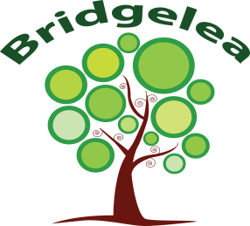

Prevent Strategy

What is the Prevent Strategy?

Prevent is a government strategy designed to stop people becoming terrorists or supporting terrorist or extremist causes.

The Prevent strategy covers all types of terrorism and extremism, including the extreme right wing, violent Islamic groups and other causes.

How does the Prevent strategy apply to Bridgelea Primary School?

From July 2015 all schools (as well as other organisations) have a duty to safeguard children from radicalisation and extremism.

This means we have a responsibility to protect children from extremist and violent views the same way that we protect them from other causes of danger.

Importantly, we provide a safe place for children to discuss these issues so they better understand how to protect themselves.

What does this mean in practice?

Many of the things that we already do in school to help children become positive, happy members of society also to contribute to the Prevent Strategy.
These include:
- Exploring other cultures and religions and promoting diversity
- Challenging prejudice and racist comments
- Developing critical thinking skills and a strong, positive self‐identity
- Promoting the spiritual, moral, social and cultural development of children, as well as British values as democracy

We also protect children from the risk of radicalisation, for example by using filters on the internet to make sure that they can’t access extremist or terrorist material, or by vetting visitors who come to the school.

Different schools will carry out the Prevent duty in different ways, depending on the age of the children and needs of the community.

Key Terms:
Extremism ‐ vocal or active opposition to fundamental British values such as democracy, the rule of law and tolerance of different faiths and beliefs
Ideology ‐ a set of belief
Terrorism ‐ a violent action against people or property, designed to create fear and advance a political, religious or ideological cause
Radicalisation ‐ the process by which a person comes to support extremism and terrorism

Frequently asked questions

How does Prevent relate to British values?

Schools have been required to promote British Values since 2014, and this will continue to be part of our response to the Prevent Strategy.

British values include:
- Democracy
- The rule of law
- Individual liberty and mutual respect
- Tolerance of different faiths and beliefs

Isn’t my child too young to learn about extremism?

The Prevent strategy is not just about discussing extremism itself, which may not be appropriate for younger children. It is also about teaching children values such as tolerance and mutual respect. We will make sure that any discussions at school are suitable for the age and maturity of the children involved.

Is extremism really a risk in our area?

Extremism can take many forms, including political, religious and misogynistic extremism. Some of these may be a bigger threat in our area than others. We aim to give the children the skills to pro‐ tect them from any extremist views they may encounter now, or later in life.

If you have any questions or concerns about the Prevent strategy and what it means for your child, please do not hesitate to con‐ tact the school.

