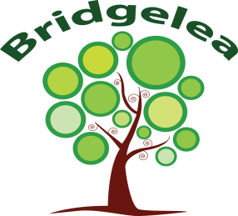
Bridgelea Primary School

Understanding Problematic and Harmful Sexualised Behaviours in School

As you are aware, your child has been referred to Bridgelea’s Outreach Service for support around the concerns of problematic and harmful sexualized behaviours they display in school. I would like to gather further information from yourself and the school in order to be able to complete an assessment and identify whether targeted 1:1 interventions or a therapeutic service may be appropriate to support your child to change their behavior.

All information will be held in the strictest confidence.

If you are happy for me to complete a consultation on behalf of your child’s school, please sign and return the reply slip below.

Research
Working Together 2015 states that research has shown that taking a systematic approach to enquiries using a conceptual model is the best way to deliver a comprehensive assessment for children.

The Chief Inspector of Probation, Liz Calderbank reported on behalf of all inspectorates ‘the behaviour of this small but significant group of children and young people can be extremely damaging, often involving other children as victims. Evidence is that these children and young people do respond to intervention and can be prevented from reoffending before developing entrenched patterns of behavior.

We are hoping to work alongside schools to support them with understanding the behaviours of children within their setting. Bridgelea will support with the Assessment, Management and Intervention delivery for the child/young person to support with bring the child back onto a healthy developmental pathway.

I give consent for my child’s __________________________________________ information to be shared with Bridgelea Primary School

Signed: ________________________________________________

Date: ________________________________________________

