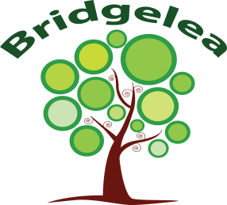

Bridgelea Primary School

Our remote learning offer explained.

Message to parents/carers:

We know your child isolating with Covid is a challenging time for you and we hope they are well at home.

We are sending resources, setting tasks and home learning for children to access while they are at home. Please encourage them to access this work if they are well enough to do so.

We know that you will do your best to carry on providing meaningful activities to your
children at this time. Please don't stress about it, do what you can and do what is right for your child.

This guide will explain-

- Our online platforms.

- Daily contact and what to expect at home in our remote offer.

- How we will meet your child’s SEN needs at home.

- E-Safety and Safeguarding.

- Contact details and useful links.

Our main online platforms-

All usernames and passwords are sent home. Please contact admin or speak to your class team if there are any issues logging on.
Platform | What you will find… | What the children can do…
Class Dojo Remember to show the LOVE 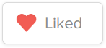 | - Your child’s class teacher will post updates from class throughout the week.  - Your child’s class teacher will message parents through this platform.  - Teachers will share pictures and videos or whole  school activities/competitions.  - Key messages are shared on here. | Children can upload pictures to their Portfolio and share their work with the teachers.  You can send messages to the staff team to keep in touch/ask any questions.
Purple Mash and Active Learn | https://www.purplemash.com/login/  Your child will be set 2Dos, to complete when they can on Purple Mash. https://www.activelearnprimary.co.uk/login?c=0&l=0  School code: cp9x- The class teacher will set reading books on active learn and other tasks. | Complete any activities at their own pace. Complete their 2Dos at their own pace.  You may read to a parent or sibling over active learn, let your Teacher know when you have read a book!
Times tables Rockstars | https://play.ttrockstars.com/auth/school/student/70735  Teachers can set times tables challenges for your child to practice using TTRS. | Practice their allotted times tables using the challenges given by your teacher.
My Maths | Tasks may be set online using my maths platforms depending on the class teacher/stage of the child.  https://www.mymaths.co.uk/ | Complete any set tasks set in your home learning on MyMaths.

What to expect from our remote offer-

- If you require a laptop to support with home learning please let us know.
- The class team will contact the children daily to explain work and check in well-being.
- Paper packs are delivered with English, Maths, motor skills and sensory play to supplement the online offer. These contain extra resources the children may need to help them to learn and access the work set.
- We are matching the curriculum covered in school with our remote offer so that children are not at a disadvantage at home. The topics covered at home and in school are the same (with some adaptions to help them to work online well). This includes maths, english, reading, PHSE, art and creative, topic and assemblies.
- If we struggle to get in touch with you or your child we may need to do a welfare visit to your home to check you are all okay.

How we will meet your child’s SEN needs at home-
Every child has different needs, and when in school they all have an individual provision map to plan how their needs are met. At home, we have considered each individual child and ensured the key elements of their provision are still being delivered remotely. This is from Section F of their EHCP. Here are examples of how your child may be accessing SEN support at home. Not all the provision will match all the children, so elements may be included in your child’s offer.

Cognition and learning.  Supporting materials for maths sent home to help with our Numicon approach. These are tailored to your child’s needs  Word mats for literacy and other topics.  Phonics interventions or daily teaching of phonics.  Lots of visual support and pictures when accessing learning.  Reading booster interventions.  Coloured overlays to help reading. | 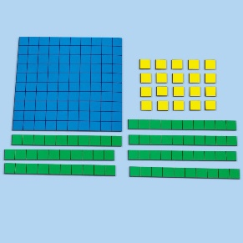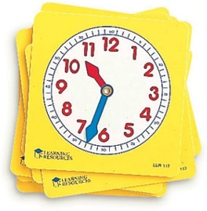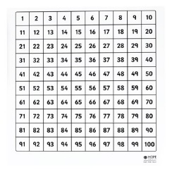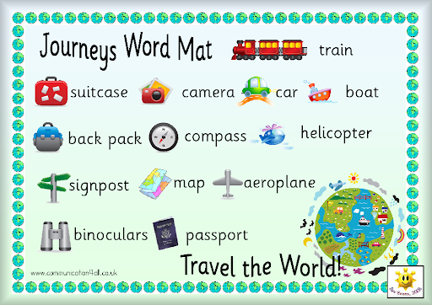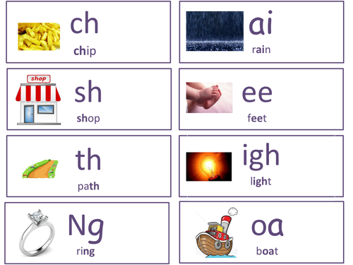
Communication and interaction.  Highly visual approach, learning with lots of pictures to support understanding.  Now/Next boards and visual timetables to support structure.  Social stories to support change and enforce routines.  Social skills support via class socialisation activities (assemblies and wellbeing activities).  We use Elklan approaches when communicating with your children and asking them questions and give them think time. | 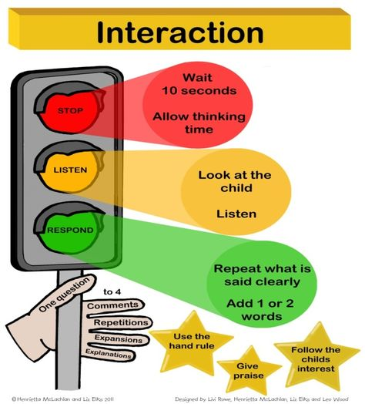  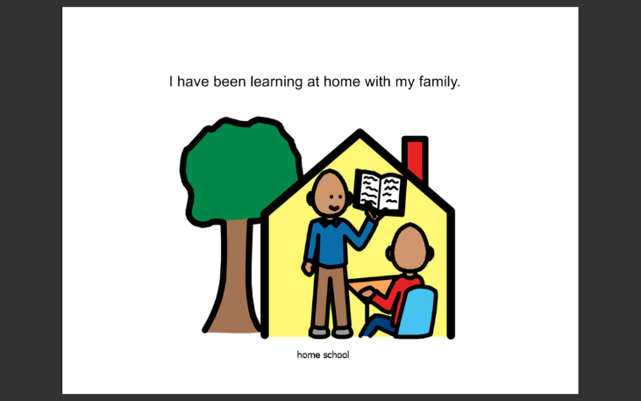
Physical and sensory needs.  Fine motor skills boxes have been made and tailored to each child’s needs and may have activities such as threading, thera-putty, tweezers and cutting activities. These will be delivered with the remote team supporting.  Gross motor skills activities are delivered in different ways- a mini sensory circuit has been developed and for children with limited space activities such as digging, lifting and pushing have been tried at home to meet their different needs.  Sensory calming activities such as sensory stories, making for calming and mindful activities are prepared and delivered where appropriate. | 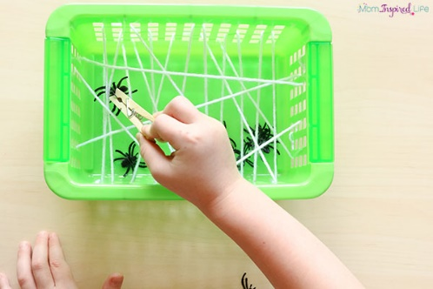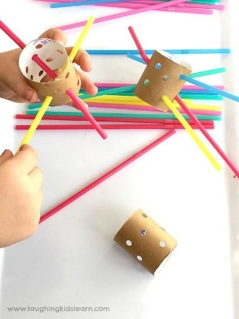  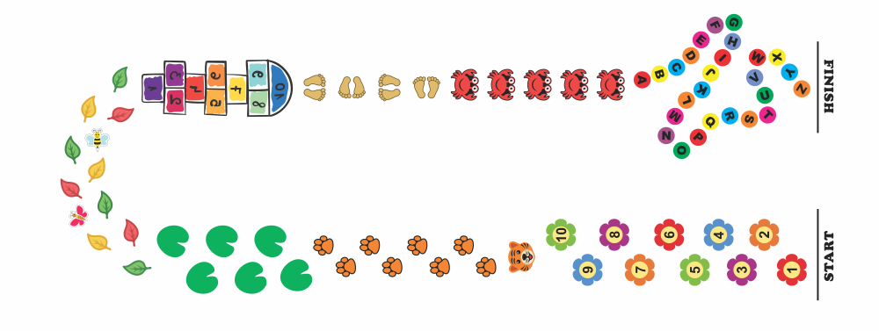
Social, Emotional and Mental Health (SEMH)  Every child at home will receive support around Emotional Scale and their Boxall Profile targets, to continue to support their emotional development.  Having access to daily check ins with staff, social contact with their peers in school will aid in them feeling “belongingness”.  Where children have specific needs around anxiety/anger their interventions will be delivered remotely.  Children who need physical bursts to help their regulation will have resources sent under the physical/sensory category. | 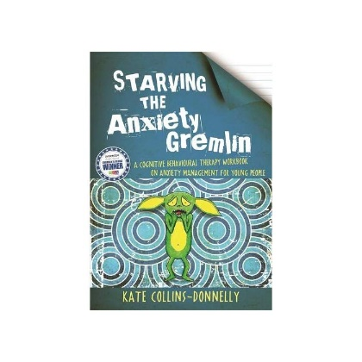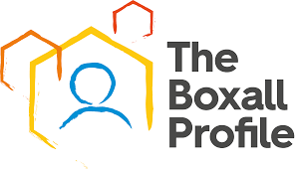  1 2 3 4 5 6 7 8 9 10

Our approach to Safeguarding and E-Safety-

To ensure your child remains safe online during remote learning,‘Think U Know’ have produced home activity packs to support parents. https://www.thinkuknow.co.uk/parents/Support-tools/home-activity-worksheets/ Each week an E-Safety activity will be sent home in your child’s pack. There will also be a parent resource posted on Class Dojo.
Our DSL is Lisa Shaw. We still have a duty to safeguard children at home and are here to support you in any difficulties you have. All contact is recorded on our CPOMs system and we may need to undertake a home visit to check on your welfare if we are unable to get in touch with you. Your child’s class team will attempt daily contact with you and your child to engage in learning activities and to generally check on your wellbeing. Please let us know if you have any issues with your phone lines or IT equipment so that we can contact you in the best way.

Useful information and contact details-

Do not worry about trying to maintain a full routine for your child like they have at school. Your child may feel ill or tired if they have Covid. However, most children do not have symptoms of Covid but need to stay at home for 5 days to stop the spread. Children may feel more comfortable and learn better with a predictable routine to the day, even if this is difficult. On the next slide is a timetable which you may like to follow or adapt to suit your child’s needs and interests. Do not feel you have to follow those timings exactly. Our aim is for children to spend around 30 – 40 minutes on a task but children work at different speeds and it is dependent on the activity and day! Some days children will be more engaged than others.

It’s best to have a visual timetable maybe the children can tick the activities but generally, try to make sure that they:
- get up and go to bed at the same time each day
- have regular meal times
- have regular breaks
- make time to be active - children are used to regular play at lunch and break times
- Consistent routines are important for behaviour and wellbeing in school and our routines at home have changed significantly. Routines support behaviour and you will be finding a new rhythm with your family.
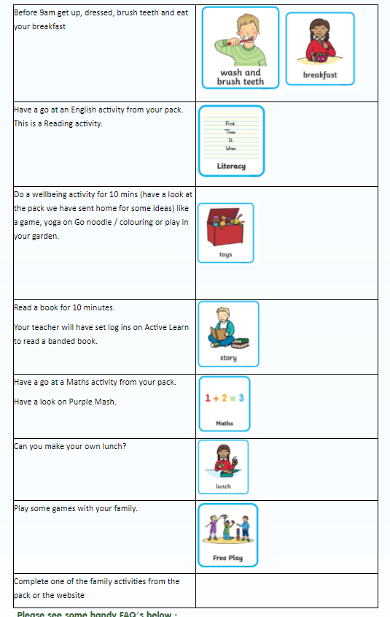
Timetable – This can be adapted, it is a rough guide…

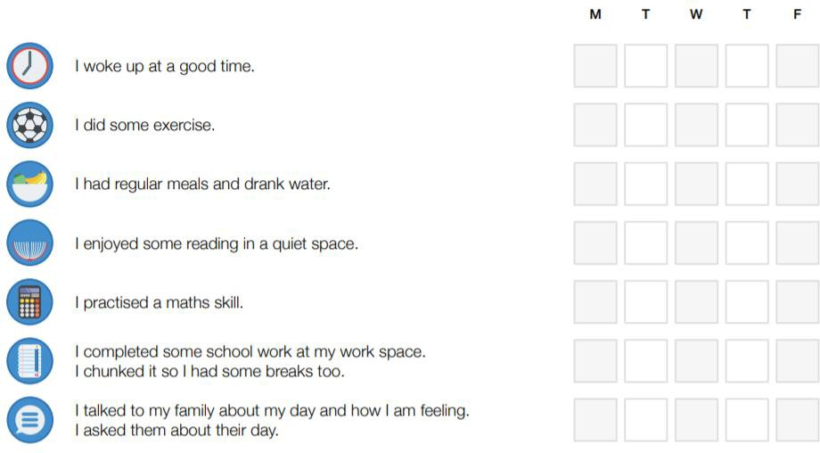
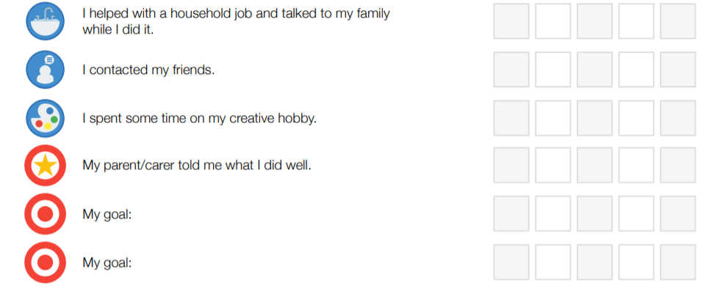

Home Learning Guide

Checklist…
You could use this checklist or you and your child/children might want to create your own.

Our website has a raft of information including videos from our SENCOs to help to explain our remote offer. This can be accessed at-

https://www.bridgelea.manchester.sch.uk

Useful phone numbers-

Admin office- Withington 0161 434 1548/ Longsight 0161 272 8716
DSL- Lisa Shaw- 07712 330424

