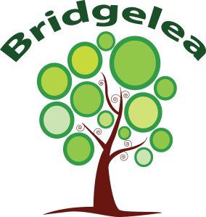
ITEM 5.3

Bridgelea Primary School Bridgelea Road Withington
Manchester M20 3FB

MEDICINE POLICY

Implemented | Feb 2021
Presented by | Caroline Cassidy
Ratified by Governors | Autumn 2023
Review Date | Autumn 2024

Article & Nurture Principle relating to this Policy
Article 24 You have the right to the best health care possible, safe water to drink, nutritious food, a clean and safe environment, and information to help you stay well.
- The importance of nurture for the development of wellbeing

Bridgelea Primary School Vision & Mission Statement
Vision “Understanding People”
Mission Statement “We work with people to build aspirations, connect, challenge, change and grow. We are an outstanding school and a proud founding member of the City of
Manchester Learning Partnership.”
  - We value SUCCESS. Children achieve academic as well as social and emotional growth.
  - We value SAFETY. We care for each other and keep each other safe.
  - We value CO-OPERATION. As a school we will endeavour to co-operate with the community to inspire and empower every individual.
  - We value COMMUNICATION. We believe that all behaviour is communication.
  - We value DEVELOPMENT. Learning is understood developmentally.
  - We value WELLBEING. We have a holistic approach to wellbeing across the school.
  - We value DIVERSITY. We celebrate each other as unique individuals with rights that we respect.
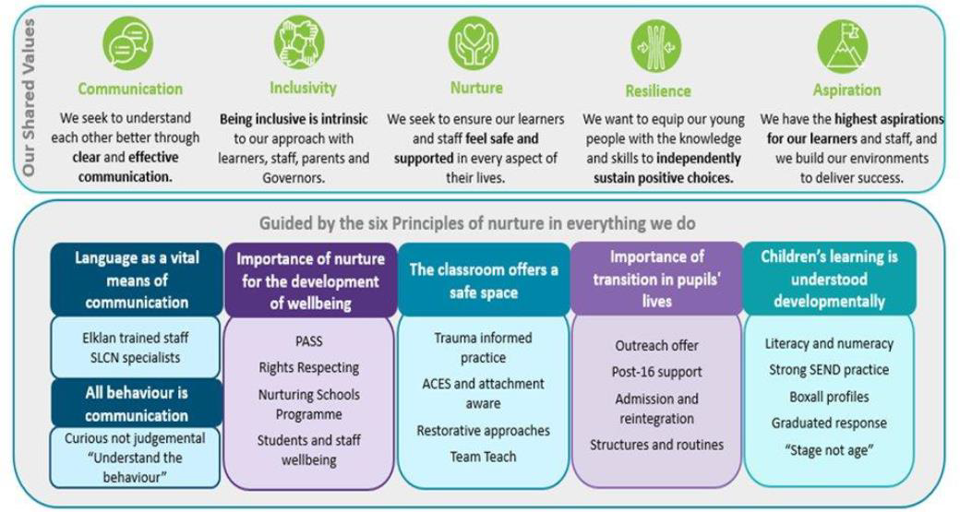
UN Rights of the Child: Bridgelea 10 Articles

Article 12
You have the right to give your opinion, and for adults to listen and take it seriously.
Article 13
You have the right to find out things and share what you think with others, by talking, drawing, writing or in any other way unless it harms or offends other people.
Article 15
You have the right to choose your own friends and join or set up groups, as long as it isn't harmful to others. Article 24
You have the right to the best health care possible, safe water to drink, nutritious food, a clean and safe environment, and information to help you stay well.
Article 27
You have the right to food, clothing, a safe place to live and to have your basic needs met. You should not be disadvantaged so that you can't do many of the things other kids can do.
Article 28
You have the right to a good quality education. You should be encouraged to go to school to the highest level you can. Article 29
Your education should help you use and develop your talents and abilities. It should also help you learn to live peacefully, protect the environment and respect other people.
Article 30
You have the right to practice your own culture, language and religion - or any you choose. Minority and indigenous groups need special protection of this right.
Article 31
You have the right to play and rest. Article 39

You have the right to help if you've been hurt, neglected or badly treated.

The Six Principles Of Nurture

The nurturing approach offers a range of opportunities for children and young people to engage with missing early nurturing experiences, giving them the social and emotional skills to do well at school and with peers, develop their resilience and their capacity to deal more confidently with the trials and tribulations of life, for life.
- Children's learning is understood developmentally
- The classroom offers a safe base
- The importance of nurture for the development of wellbeing
- Language is a vital means of communication
- All behaviour is communication
- The importance of transition in children's lives

Bridgelea Primary School Policy on Medicines in School

The purpose of this policy is to ensure safe practice in the management of medicines in school and takes account of guidance from the “Managing Medicines in School and Early Years Settings” document. (DfES, 2005) and “Supporting Pupils at School with Medical Conditions” (May 2014).

It should be noted that there is no legal duty that requires school staff to administer medicines but that we at Bridgelea are willing to undertake this task to enable regular attendance, under the following conditions:

- Procedures for managing prescription medicines which need to be taken during the school day Parents should keep children at home when they are acutely unwell. Medicines should only be taken to school when essential - that is, where it would be detrimental to a child’s health if the medicine were not administered during the school day. Bridgelea will only accept medicines that have been prescribed by a doctor, dentist, nurse prescriber or pharmacist prescriber. Medicines should always be provided in the original container as dispensed by a pharmacist and include the prescriber’s
instructions for administration. Parents can request a label and original packaging for ‘Care at the Chemist’ services. Parents can also request two properly labelled packets from a pharmacist at the
time of prescription for medication which will need to be administered at home and school, to ensure safe administration for the child.

Bridgelea will never accept medicines that have been taken out of the container as originally dispensed, nor make changes to dosages on parental instructions.
It is helpful, where clinically appropriate, if medicines are prescribed in dose frequencies which enable it to be taken outside school hours. Parents will be encouraged to ask the prescriber about this. It is to be noted that medicines that need to be taken three times a day could be taken in the morning, after school hours and at bedtime. Nevertheless, many children will need to take medicines during the day at some time during their time in school. This will usually be for a short period only, perhaps to finish a course of antibiotics or to apply a lotion. To allow children to do this will minimise the time that they need to be absent. However, such medicines should only be taken to school where

it would be detrimental to a child’s health if it were not administered during the school day. A child under 16 should never be given aspirin or medicines containing ibuprofen unless prescribed by a doctor.

Controlled Drugs
The supply, possession and administration of some medicines are controlled by the Misuse of Drugs Act and its associated regulations. Some may be prescribed as medication for use by children, e.g. methylphenidate. Only trained staff may administer a controlled drug to the child for whom it has been prescribed. Staff administering medicine should do so in accordance with the prescriber’s instructions. Controlled drugs will be kept in a locked non-portable container or cupboard. A controlled drug, as with all medicines, should be returned to the parent when no longer required to arrange for safe disposal (by returning the unwanted supply to the local pharmacy). If this is not possible, it should be returned to the dispensing pharmacist (details should be on the label). Misuse of a controlled drug, such as passing it to another child for use, is an offence, and falls within the school policies relating to disciplinary matters and illegal substances.

Refusal of Medicine
If a child refuses to take prescribed medication, staff should not force them to do so, but should note this in the records and follow agreed procedures as follows:
- Contact parent/guardian and advise them of the situation.
- Invite the parent/guardian to school to administer the medication.
- If the child continues to refuse to take medication that is essential to their health and wellbeing, the school reserves the right to send the child home.
- If refusal to take medication results in an emergency, the schools emergency procedures should be followed.

Procedures for managing medicines on trips and outings
School documentation relating to visits requires the trip leader to consider the medical needs of participating pupils, and to seek advice from parents where a medical issue might be relevant during the visit. The trip leader will be responsible for (or delegate a member of staff to be responsible for) first aid, though the level of medical training of that person will vary according to the scale, duration and destination of the visit, and any issues raised by the risk assessment. This person will be responsible for the safety and administration of medicines.

Statement on the roles and responsibility of staff
All staff should be familiar with normal precautions for avoiding infection and follow basic hygiene procedures. All staff should be prepared to help pupils in medical need, but should only do so up to the extent of their training: for example, staff with only basic first aid training will usually request the assistance of trained first aid staff. Staff should use protective disposable gloves and take care when dealing with spillages of blood or other body fluids and disposing of dressings or equipment.

Statement on parental responsibilities in respect of their child’s medical needs
Parents should provide full information about their child’s medical needs, including details on medicines their child needs. Where parents fail to provide the information required in this policy, including that required for the school’s medical form, the school will not administer medication.

- The need for prior written agreement from parents for any prescribed medicines to be given to a child No child should be given medicines without their parent’s consent. The school medical form is available from the school office. Parents should attend school with the medication and sign the record. This also should be countersigned. Any member of staff giving medicines to a child should check: the child’s name, prescribed dose, expiry date, and any written instructions provided by the prescriber on the label or container. If in doubt about any procedure staff should not administer the medicines but check with the parents or a health professional before taking further action. If staff have any other concerns related to administering medicine to a particular child, the issue should be discussed with the parent, if appropriate, or with a health professional attached to the school or setting.

Non-Prescribed Medicines
Bridgelea will never give a non-prescribed medicine to a pupil unless a member of the Senior Leadership Team / a member of staff is trained in administering medicines agrees that this is necessary and where there is specific permission from parents/carers. This must be recorded on CPOMS and on the medicine form kept in the office.

The school policy on assisting children with long-term or complex medical needs
The school SENCO will identify children with long-term medical needs. There is a medical record for each site located on the office wall and a copy is kept in the medical file in the office. For children who attend hospital appointments on a regular basis, special arrangements may also be necessary. Health care requirements will be made known by a health care plan, following consultation with the parents and (where appropriate) relevant health professionals. This may include: details of a child’s condition, special requirements e.g. dietary needs, pre-activity precautions; any side effects of the medicines; what constitutes an emergency, who to contact, what action to take, and what not to do.

Policy on children carrying and taking their medicines themselves
Dependent upon the age and stage of the pupils, it may be appropriate for children to carry emergency medication such as asthma inhalers and adrenaline pens with them. This will be decided by the classroom staff dependent on the cohort. Such medications must be easily available in the event of an emergency.

Staff training in dealing with medical needs
All named First Aid staff participate in a course in first aid training from an accredited provider. All staff will receive annual refresher training on the common conditions of Asthma, Epilepsy, Diabetes and Anaphylaxis.

Record keeping
Parents should tell the school or setting about the medicines that their child needs to take and provide details of any changes to the prescription or the support required. However staff should make sure that this information is the same as that provided by the prescriber. Medicines should always be provided in the original container as dispensed by a pharmacist and include the
prescriber’s instructions. In all cases it is necessary to check that written details include: name of child, name of medicine dose, method of administration, time/frequency of administration, any side effects and expiry date. Staff will record details of medicines in a standard format. Staff should check that any details provided by parents, or in particular cases by a paediatrician or specialist nurse, are consistent with the instructions on the container. Staff are to complete and sign a record each time

they give medicine to a child, which will then be countersigned by a second member of staff. ¹Good records help demonstrate that staff have exercised a duty of care, and provide proof that they have followed agreed procedures. This should also be recorded on CPOMS by the person who has administered the medication.

Safe storage of medicines
Large volumes of medicines should not be stored. Staff should only store, supervise and administer medicine that has been prescribed for an individual child. Medicines should be stored strictly in accordance with product instructions (paying particular to note temperature) and in the original container in which dispensed. Staff should ensure that the supplied container is clearly labelled with the name of the child, the name and dose of the medicine and the frequency of administration. This should be easy if medicines are only accepted in the original container as dispensed by a pharmacist in accordance with the prescriber’s instructions. Where a child needs two or more prescribed medicines, each should be in a separate container. Nonhealthcare staff should never transfer medicines from their original containers. Children should know where their own medicines are stored and who holds the key. All emergency medicines, such as asthma inhalers and adrenaline pens, should be readily available to children and should not be locked away. Where ever possible, emergency medications should be kept in the classroom where the pupil is usually based. Other non-emergency medicines should generally be kept in a secure place not accessible to children. A few medicines need to be refrigerated. They can be kept in a refrigerator containing food but should be in an airtight container and clearly labelled. There should be restricted access to a refrigerator holding medicines.

Disposal of Medicines
Parents should collect medicines held at the end of each term. If parents do not collect all medicines, they should be taken by a member of staff to a local pharmacy for safe disposal at the end of each academic year. Sharps boxes should always be used for the disposal of needles. Sharps boxes can be obtained by parents on prescription from the child’s GP or paediatrician. Collection and disposal of the boxes should be arranged with the Local Authority’s environmental services.

Access to the school’s emergency procedures
All children should know what to do in the event of an emergency, such as telling a member of staff. All staff should know how to call the emergency services. All staff should also know who is responsible for carrying out emergency procedures in the event of need. A member of staff should always accompany a child taken to hospital by ambulance, and should stay until the parent arrives. Health professionals are responsible for any decisions on medical treatment when parents are not available. Staff should only take children to hospital in their own car in truly exceptional circumstances; it is safer to call an ambulance.

Risk assessment and management procedures
All qualifying medical incidents are recorded on school’s accident forms. Risk assessments are included in the planning of school visits. They are also undertaken in relation to the school site by premises staff. Bridgelea can contact the school nurse provided by the local Primary Care Trust for advice and training.

¹ In case of administering prescribed medication in an emergency, staff members should not delay administering medication if there is not another staff member present if this would place the child in danger.

Date of policy: October 2023

Date of next review: October 2024
Reviewed by Caroline Gibson and Amy Robinson (SENCO)

